# United States Natural Disaster Service

Design Document

Table of Contents

United States Natural Disaster Service 1

Problem Statement 3

Use Cases 3

U1: Disaster Details 3

U2: Topological Map 3

U3: Create Disaster 4

U4: Update Disaster 4

Project Scope 4

In Scope 4

Out of Scope 4

Open Questions 5

Functional Requirements 5

U1: Disaster Details 5

FR 1.1: valid_inputs_get_disaster_returns_disaster_details 5

FR 1.2: no_matching_disaster_get_disaster_not_found_error 5

U2: Topological Map 6

FR 2.1: current_disasters_map_current_disasters_returns_disasters 6

FR 2.2: no_current_disasters_map_current_disasters_returns_empty_map 6

FR 2.3: click_on_disaster_area_renders_popup 6

U3: Create Disaster 7

FR 3.1: valid_administrator_create_disaster_creates_disaster 7

FR 3.2: unauthorized_user_create_disaster_forbidden_error 7

FR 3.3: missing_data_create_disaster_bad_request_error 7

FR 3.4: future_start_date_create_disaster_bad_request_error 8

FR 3.5: invalid_disaster_type_create_disaster_bad_request_error 8

FR 3.6: invalid_severity_create_disaster_bad_request_error 8

FR 3.7 negative_deaths_create_disaster_bad_request_error 8

FR 3.8: negative_injuries_create_disaster_bad_request_error 9

FR 3.9: negative_financial_impact_create_disaster_bad_request_error 9

FR 3.10: too_many_decimals_financial_impact_create_disaster_bad_request_error 9

FR 3.11: invalid_location_create_disaster_bad_request_error 9

FR 3.12: invalid_area_create_disaster_bad_request_error 9

U4: Update Disaster 10

FR 4.1: valid_administrator_update_disaster_creates_disaster 10

FR 4.2: unauthorized_user_update_disaster_forbidden_error 10

FR 4.3: disaster_does_not_exist_update_disaster_not_found_error 10

FR 4.4: missing_data_update_disaster_bad_request_error 10

FR 4.5: future_start_date_update_disaster_bad_request_error 11

FR 4.6: future_end_date_update_disaster_bad_request_error 11

FR 4.7: invalid_disaster_type_update_disaster_bad_request_error 11

FR 4.8: invalid_severity_update_disaster_bad_request_error 12

FR 4.9: negative_deaths_update_disaster_bad_request_error 12

FR 4.10: negative_injuries_update_disaster_bad_request_error 12

FR 4.11: negative_financial_impact_update_disaster_bad_request_error 12

FR 4.12: too_many_decimals_financial_impact_update_disaster_bad_request_error 13

FR 4.13: invalid_location_update_disaster_bad_request_error 13

FR 4.14: invalid_area_update_disaster_bad_request_error 13

UX Design 14

Mockups 14

Map Page 14

Popup 14

Details Page 15

Proof Of Concept 15

Map Page 15

Popup 15

Proposed Architecture 16

High-Level Overview 16

Architectural Overview 16

Architectural Diagram 16

Chosen Technologies 16

Technology 1: <Name> 16

Alternative Technologies 16

Alternative 1: <Name> 16

Service Overview 16

API Design 17

Public Models 17

Disaster 17

Requests 18

Responses 19

Endpoints 20

Disaster Endpoints 20

Data Design 22

Table 1: <Name> 22

Development Operations 22

Source Control & Standards 22

Coding Language(s) & Standards 23

<Component> : <Language 1, ex: Python 3.11> 23

Containerization / Build Platform 23

Component 23

Build Platform 23

Component 1 23

Ex: Docker 23

Testing Details 23

Code Review Process 23

Deployment Process 24

Logging, Monitoring, & Metrics 24

Tasks and Milestones 24

Milestone 1: <Title> 24

Task 1.1: <Title> 24

Appendix 1: Definition of Terms 24

Appendix 2: Citations 25

Appendix 3: Design Document Resources <You can delete later> 25

Appendix 4: Diagram Sources 26

API Design 26

Disaster Models 26

Request Models 27

Response Models 28

# Problem Statement

The United States continues to face a number of natural disasters on a regular basis. The goal of our service is to track the statistics of natural disasters across the United States.

In this design document, we will outline how we plan to implement the United States Natural Disaster Service. This service lets us track natural disasters by disaster name, state, disaster type, danger level, and date.

# Use Cases

## U1: Disaster Details

As a United States Natural Disaster Service customer, I want to get a detailed explanation of a disaster when I open a disaster details page.

## U2: Topological Map

As a United States Natural Disaster Service customer, I want to be able to access a topological map showing ongoing natural disasters.

## U3: Create Disaster

As a United States Natural Disaster Service administrator, I want to be able to create new logs of natural disasters.

## U4: Update Disaster

As a United States Natural Disaster Service administrator, I want to be able to update logs of existing natural disasters.

# Project Scope

## In Scope

* Detailed explanation of a disaster on a disaster details page, including:
  + ID
  + Area
    - Polygon (Points – Lattitude & Longitude)
  + Death toll
  + Injuries
  + Financial Impact
  + Start Date
  + End Date
  + Severity
  + Type of disaster
* Logging the following disaster types:
  + Earth quakes
  + Tornadoes
  + Hurricanes
  + Fires
  + Floods
  + Volcano Eruptions
  + Blizzards
  + Tsunamis
* Topological map showing ongoing natural disasters. Clicking on a disaster will show:
  + Type of disaster
  + Start Date
  + Death toll
  + Injuries
  + Severity
* Administrators are able to create new logs of natural disasters
* Administrators are able to update existing natural disasters

## Out of Scope

* Providing a list of resources for an ongoing natural disasters
* User profile creation
* Integration with natural disaster resources, such as the USGS and NWS
* Other disasters – hail, blackouts/brownouts, droughts
* Heat map showing the density of disasters by location
* Disaster routes / forecast
* Deleting natural disaster logs
* Reporting erroneous natural disaster logs / Fact Checking
* Allowing non-administrator users to add natural disasters
* Granular incidents within an overall disaster
* Customization of map colors
* Currency selection
* Time Zone selection
* Admin-specific UI

# Open Questions

*Use this space for any questions you still need to answer as you update/review this document.*

1. How can we enforce authentication and authorization on creating & updating disasters?
2. What do we need to consider for internationalization and localization of details?
3. Do we want to add names to the disaster entries?

# Functional Requirements

## U1: Disaster Details

### FR 1.1: valid_inputs_get_disaster_returns_disaster_details

GIVEN:

* Disaster ID
* Existing disaster with the given disaster ID

WHEN:

* User gets the disaster details

THEN:

* Return valid disaster details, including:
  + ID
  + Death toll
  + Injuries
  + Financial Impact
  + Start Date
  + End Date
  + Severity
  + Type of disaster

### FR 1.2: no_matching_disaster_get_disaster_not_found_error

GIVEN:

* Disaster ID
* No existing disaster with the given disaster ID

WHEN:

* User gets the disaster details

THEN:

* UX: Return a 404 – Not Found Error
* Backend: Return NotFoundError

## U2: Topological Map

### FR 2.1: current_disasters_map_current_disasters_returns_disasters

GIVEN:

* Existing ongoing disasters

WHEN:

* User gets the topological map of current disasters

THEN:

* UX: Return a map rendering the current disasters
  + Each disaster has its own area shown on the map
* Backend: Return a list of ongoing disasters
  + Disasters filtered to those with no end date
  + For each disaster, return:
    - ID
    - Area
      * Polygon (Points – Lattitude & Longitude)
    - Start Date
    - Severity
    - Type of disaster

### FR 2.2: no_current_disasters_map_current_disasters_returns_empty_map

GIVEN:

* No existing ongoing disasters

WHEN:

* User gets the topological map of current disasters

THEN:

* UX: Return a map with no disasters shown
* Backend: Return an empty list

### FR 2.3: click_on_disaster_area_renders_popup

GIVEN:

* Topological map of current disasters with current disasters

WHEN:

* User clicks on a disaster’s area

THEN:

* UX: Render pop-up of disaster details on map, including:
  + Start Date
  + Severity
  + Type of disaster
  + Link to disaster details page for the given disaster
    - Type of disaster

## U3: Create Disaster

### FR 3.1: valid_administrator_create_disaster_creates_disaster

GIVEN:

* An authenticated, authorized administrator
* A valid disaster, including:
  + Area
    - Polygon (Points – Lattitude & Longitude)
  + Death toll
  + Injuries
  + Financial Impact
  + Start Date
  + Severity
  + Type of disaster

WHEN:

* User creates a disaster

THEN:

* Disaster is added to data store, including:
  + Generated ID
  + Area
    - Polygon (Points – Lattitude & Longitude)
  + Death toll
  + Injuries
  + Financial Impact
  + Start Date
  + End Date (NULL)
  + Severity : 1-5
  + Type of disaster

### FR 3.2: unauthorized_user_create_disaster_forbidden_error

GIVEN:

* An unauthorized user

WHEN:

* User creates a disaster

THEN:

* Return a 403 Forbidden error

### FR 3.3: missing_data_create_disaster_bad_request_error

GIVEN:

* A valid administrator password
* A disaster, missing one or more of the following fields:
  + Area
    - Polygon (Points – Lattitude & Longitude)
  + Death toll
  + Injuries
  + Financial Impact (USD)
  + Start Date
  + Severity
  + Type of disaster

WHEN:

* User creates a disaster

THEN:

* Return a 400 Bad Request error

### FR 3.4: future_start_date_create_disaster_bad_request_error

GIVEN:

* A valid administrator password
* A disaster, with a start date set for the future

WHEN:

* User creates a disaster

THEN:

* Return a 400 Bad Request error

### FR 3.5: invalid_disaster_type_create_disaster_bad_request_error

GIVEN:

* A valid administrator password
* A disaster, with a non-supported disaster type

WHEN:

* User creates a disaster

THEN:

* Return a 400 Bad Request error

### FR 3.6: invalid_severity_create_disaster_bad_request_error

GIVEN:

* A valid administrator password
* A disaster, with a severity <= 0 or >5

WHEN:

* User creates a disaster

THEN:

* Return a 400 Bad Request error

### FR 3.7 negative_deaths_create_disaster_bad_request_error

GIVEN:

* A valid administrator password
* A disaster, with a death toll < 0

WHEN:

* User creates a disaster

THEN:

* Return a 400 Bad Request error

### FR 3.8: negative_injuries_create_disaster_bad_request_error

GIVEN:

* A valid administrator password
* A disaster, with injuries < 0

WHEN:

* User creates a disaster

THEN:

* Return a 400 Bad Request error

### FR 3.9: negative_financial_impact_create_disaster_bad_request_error

GIVEN:

* A valid administrator password
* A disaster, with financial_impact < 0.00

WHEN:

* User creates a disaster

THEN:

* Return a 400 Bad Request error

### FR 3.10: too_many_decimals_financial_impact_create_disaster_bad_request_error

GIVEN:

* A valid administrator password
* A disaster, with financial_impact with more than 2 decimal pales

WHEN:

* User creates a disaster

THEN:

* Return a 400 Bad Request error

### FR 3.11: invalid_location_create_disaster_bad_request_error

GIVEN:

* A valid administrator password
* A disaster, with an invalid location

WHEN:

* User creates a disaster

THEN:

* Return a 400 Bad Request error

### FR 3.12: invalid_area_create_disaster_bad_request_error

GIVEN:

* A valid administrator password
* A disaster, with an invalid area

WHEN:

* User creates a disaster

THEN:

* Return a 400 Bad Request error

## U4: Update Disaster

### FR 4.1: valid_administrator_update_disaster_creates_disaster

GIVEN:

* An authenticated, authorized administrator
* A valid disaster, including:
  + ID
  + Area
    - Polygon (Points – Lattitude & Longitude)
  + Death toll
  + Injuries
  + Financial Impact
  + Start Date
  + End Date (optional)
  + Severity
  + Type of disaster
* An existing disaster for the provided ID

WHEN:

* User updates a disaster

THEN:

* Disaster is updated with provided disaster information in datastore
  + ID is not updated

### FR 4.2: unauthorized_user_update_disaster_forbidden_error

GIVEN:

* An authorized user

WHEN:

* User updates a disaster

THEN:

* Return a 403 Forbidden error

### FR 4.3: disaster_does_not_exist_update_disaster_not_found_error

GIVEN:

* A valid administrator password
* A valid disaster
* No existing disaster with a matching ID

WHEN:

* User updates a disaster

THEN:

* Return a 404 Not Found error

### FR 4.4: missing_data_update_disaster_bad_request_error

GIVEN:

* A valid administrator password
* A disaster, missing one or more of the following fields:
  + ID
  + Area
    - Polygon (Points – Lattitude & Longitude)
  + Death toll
  + Injuries
  + Financial Impact (USD)
  + Start Date
  + Severity
  + Type of disaster
* An existing disaster with a matching ID

WHEN:

* User updates a disaster

THEN:

* Return a 400 Bad Request error

### FR 4.5: future_start_date_update_disaster_bad_request_error

GIVEN:

* A valid administrator password
* A disaster, with a start date set for the future
* An existing disaster with a matching ID

WHEN:

* User updates a disaster

THEN:

* Return a 400 Bad Request error

### FR 4.6: future_end_date_update_disaster_bad_request_error

GIVEN:

* A valid administrator password
* A disaster, with an end date set for the future
* An existing disaster with a matching ID

WHEN:

* User updates a disaster

THEN:

* Return a 400 Bad Request error

### FR 4.7: invalid_disaster_type_update_disaster_bad_request_error

GIVEN:

* A valid administrator password
* A disaster, with a non-supported disaster type
* An existing disaster with a matching ID

WHEN:

* User updates a disaster

THEN:

* Return a 400 Bad Request error

### FR 4.8: invalid_severity_update_disaster_bad_request_error

GIVEN:

* A valid administrator password
* A disaster, with a severity <= 0 or > 5
* An existing disaster with a matching ID

WHEN:

* User updates a disaster

THEN:

* Return a 400 Bad Request error

### FR 4.9: negative_deaths_update_disaster_bad_request_error

GIVEN:

* A valid administrator password
* A disaster, with a death toll < 0
* An existing disaster with a matching ID

WHEN:

* User updates a disaster

THEN:

* Return a 400 Bad Request error

### FR 4.10: negative_injuries_update_disaster_bad_request_error

GIVEN:

* A valid administrator password
* A disaster, with injuries < 0
* An existing disaster with a matching ID

WHEN:

* User updates a disaster

THEN:

* Return a 400 Bad Request error

### FR 4.11: negative_financial_impact_update_disaster_bad_request_error

GIVEN:

* A valid administrator password
* A disaster, with a financial impact < 0.00
* An existing disaster with a matching ID

WHEN:

* User updates a disaster

THEN:

* Return a 400 Bad Request error

### FR 4.12: too_many_decimals_financial_impact_update_disaster_bad_request_error

GIVEN:

* A valid administrator password
* A disaster, with a financial impact with more than 2 decimals
* An existing disaster with a matching ID

WHEN:

* User updates a disaster

THEN:

* Return a 400 Bad Request error

### FR 4.13: invalid_location_update_disaster_bad_request_error

GIVEN:

* A valid administrator password
* A disaster, with an invalid location
* An existing disaster with a matching ID

WHEN:

* User updates a disaster

THEN:

* Return a 400 Bad Request error

### FR 4.14: invalid_area_update_disaster_bad_request_error

GIVEN:

* A valid administrator password
* A disaster, with an invalid area
* An existing disaster with a matching ID

WHEN:

* User updates a disaster

THEN:

* Return a 400 Bad Request error

# UX Design

## Mockups

### Map Page

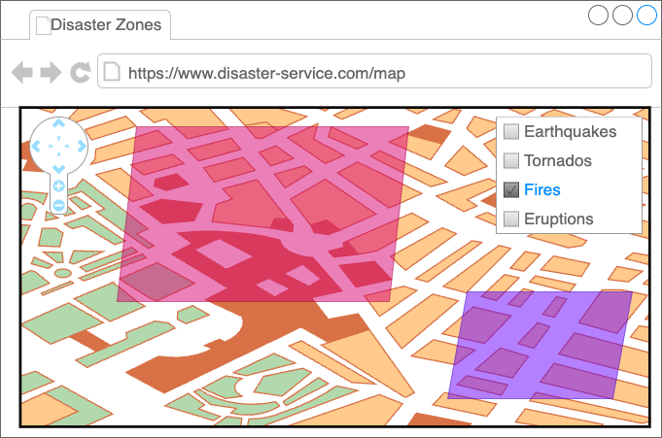

### Popup

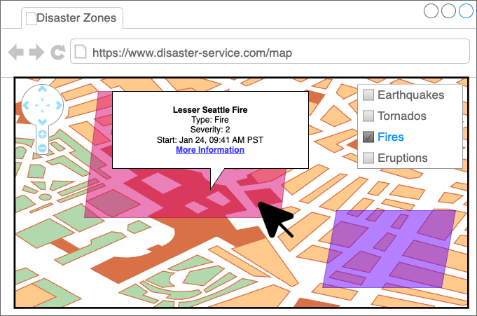

### Details Page

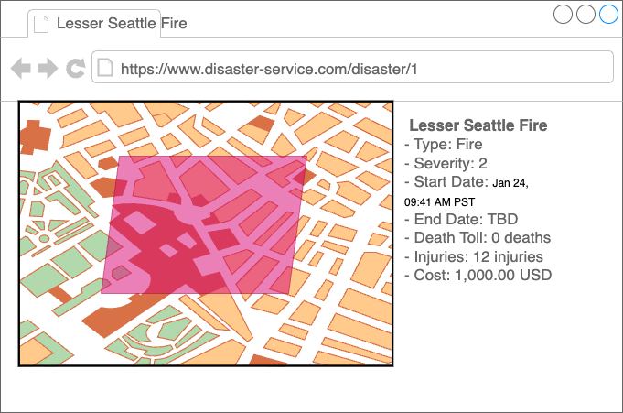

## Proof Of Concept

### Map Page

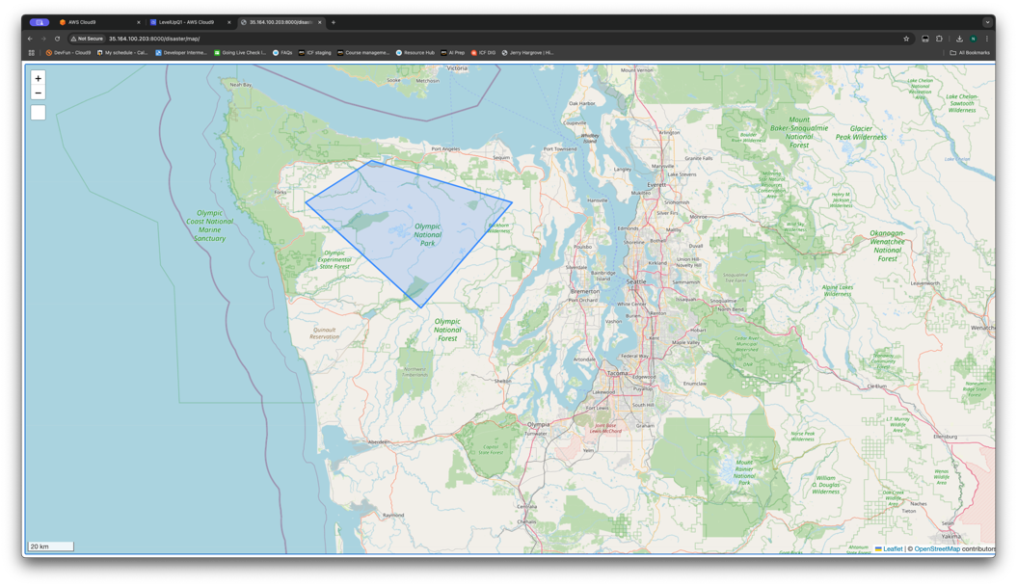

### Popup

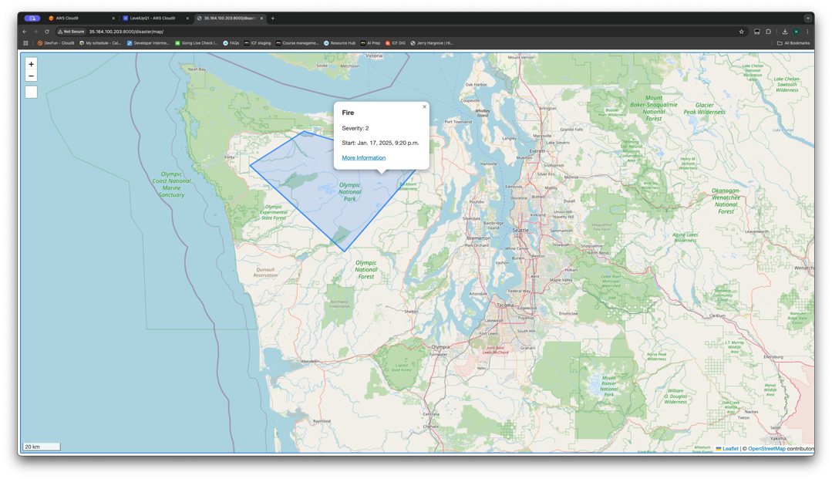

# Proposed Architecture

*Describe broadly how you are proposing to solve for the requirements you described earlier.*

## High-Level Overview

Our design follows a [Three-Tier architecture](https://docs.aws.amazon.com/whitepapers/latest/serverless-multi-tier-architectures-api-gateway-lambda/welcome.html), to more loosely couple disaster information and the presentation logic.

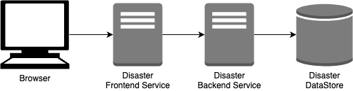

## Architectural Overview

*This should include what web services or other technologies you plan to use, as well as an architecture diagram.*

*You should describe your technical decisions, and argue why the technologies you chose are reasonable. Describe how each component will behave as part of your system.*

## Architectural Diagram

<Diagram>

## Chosen Technologies

### Technology 1: <Name>

## Alternative Technologies

*Describe alternative technologies or strategies, and why you did not choose to use them.*

### Alternative 1: <Name>

## Service Overview

*This may include class diagram(s) showing what components you are planning to build.*  
*You should argue why this architecture (organization of components) is reasonable. That is, why it represents a good data flow and a good separation of concerns. Where applicable, argue why this architecture satisfies the stated requirements.*

# API Design

## Public Models

### Disaster

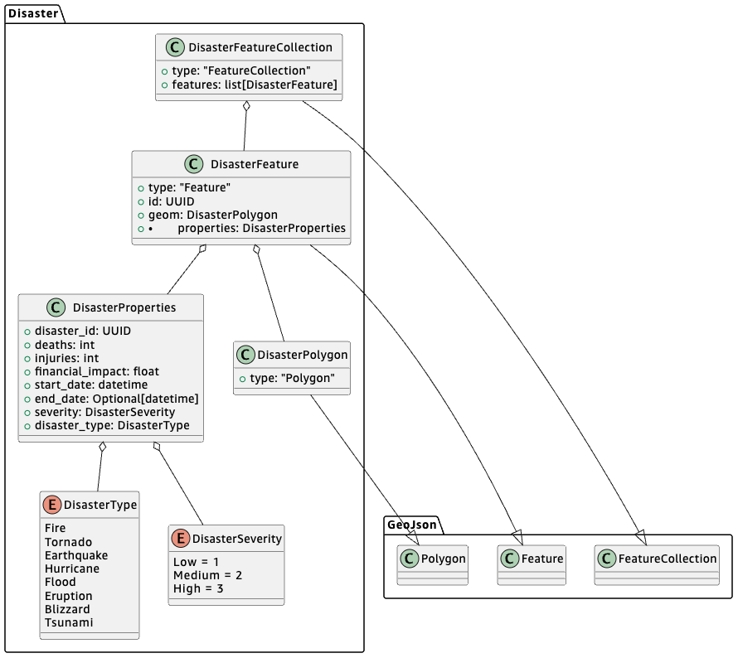

#### DisasterSeverity (Enum)

* “Low” = 1
* “Medium” = 2
* “High” = 3

#### DisasterType (Enum)

* “Earthquake” = “Earthquake”
* “Tornado” = “Tornado”
* “Hurricane” = “Hurricane”
* “Fire” = “Fire”
* “Flood” = “Flood”
* “Eruption” = “Eruption”
* “Blizzard” = “Blizzard”
* “Tsunami” = “Tsunami”

#### DisasterProperties

* disaster_id: str (UUID)
* deaths: int (>=0)
* injuries: int (>=0)
* financial_impact: float (2 decimal, >= 0.00)
* start_date: datetime
* end_date: Optional[datetime]
* severity: [DisasterSeverity](#_DisasterSeverity_(Enum))
* disaster_type: [DisasterType](#_DisasterType_(Enum))

#### DisasterPolygon

* type: str (“Polygon”)
* extends [GeoJson Polygon](https://datatracker.ietf.org/doc/html/rfc7946#section-3.1.6)

#### DisasterFeature

* type: str (“Feature”)
* properties: DisasterProperties
* geom: DisasterPolygon
* extends [GeoJson Feature](https://datatracker.ietf.org/doc/html/rfc7946#section-3.2)

#### DisasterFeatureCollection

* type: str (“FeatureCollection”)
* features: list[DisasterFeature]
* extends [GeoJson FeatureCollection](https://datatracker.ietf.org/doc/html/rfc7946#section-3.3)

### Requests

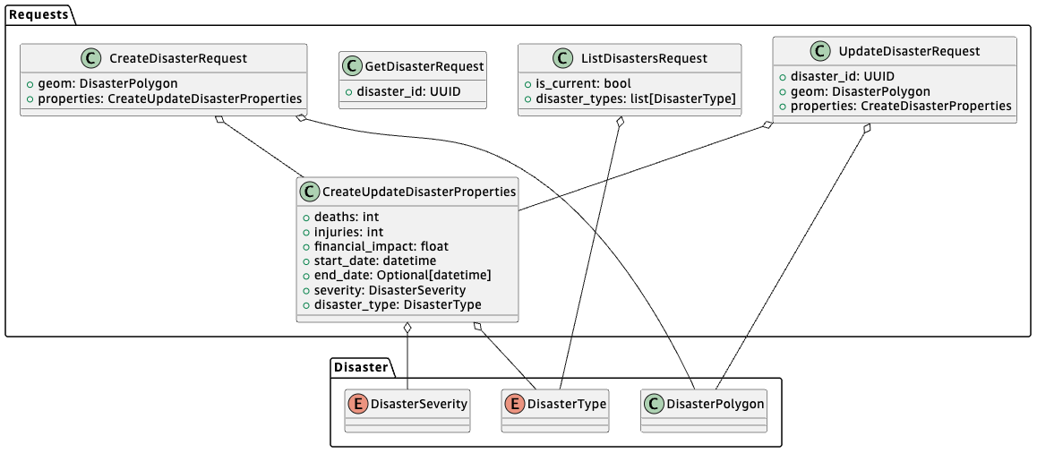

#### CreateUpdateDisasterProperties

* deaths: int (>=0)
* injuries: int (>=0)
* financial_impact: float (2 decimal, >= 0.00)
* start_date: datetime
* end_date: Optional[datetime]
* severity: [DisasterSeverity](#_DisasterSeverity_(Enum))
* disaster_type: [DisasterType](#_DisasterType_(Enum))

#### CreateDisasterRequest

* geom: DisasterPolygon
* properties: CreateUpdateDisasterProperties

#### UpdateDisasterRequest

* disaster_id: str (UUID)
* geom: DisasterPolygon
* properties: CreateUpdateDisasterProperties

#### GetDisasterRequest

* disaster_id: str (UUID)

#### ListDisastersRequest

* is_current: bool
* disaster_types: list[[DisasterType](#_DisasterType_(Enum))]

### Responses

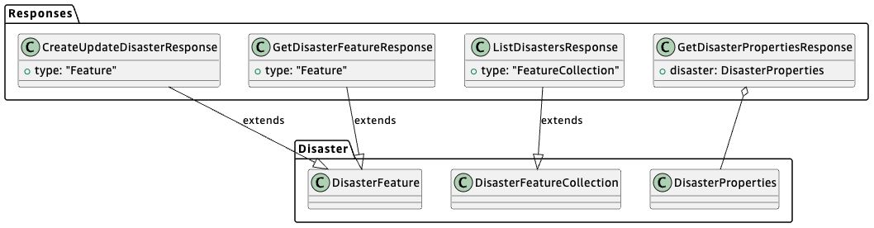

#### CreateUpdateDisasterResponse

* type: str (“Feature”)
* extends DisasterFeature

#### GetDisasterPropertiesResponse

* disaster: DisasterProperties

#### GetDisasterFeatureResponse

* type: str (“Feature”)
* extends DisasterFeature

#### ListDisastersResponse

* type: str (“FeatureCollection”)
* extends DisasterFeatureCollection

## Endpoints

### Disaster Endpoints

#### ListDisasters

Method:

* GET

Path:

* /disaster?is_current={is_current}&disaster_type={disaster_type}&disaster_type={disaster_type}

Request:

* ListDisastersRequest
  + {is_current} -> is_current
  + {disaster_type} -> disaster_types
    - Multiple: Collect into a list

Response:

* Status: 200
* ListDisastersResponse
  + `features` is empty if no disasters matching query params is found

Error Responses:

* 500: internal server error

#### GetDisasterFeature

Method:

* GET

Path:

* /disaster/{disaster_id}

Request:

* GetDisasterRequest
  + {disaster_id} -> disaster_id

Response:

* Status: 200
* GetDisasterFeatureResponse

Error Responses:

* 404: no disaster found for given ID
* 500: internal server error

#### GetDisasterProperties

Method:

* GET

Path:

* /disaster/{disaster_id}/properties

Request:

* GetDisasterRequest
  + {disaster_id} -> disaster_id

Response:

* Status: 200
* GetDisasterPropertiesResponse

Error Responses:

* 404: no disaster found for given ID
* 500: internal server error

#### CreateDisaster

Method:

* POST

Path:

* /disaster

Header:

* Authorization: Bearer {token}

Request:

* CreateDisasterRequest (body)

Response:

* Status: 200
* CreateUpdateDisasterResponse

Error Responses:

* 401: unauthorized request
* 500: internal server error

#### UpdateDisaster

Method:

* PUT

Path:

* /disaster/{disaster_id}

Header:

* Authorization: Bearer {token}

Path parameters:

* disaster_id: str (UUID)

Body:

* UpdateDisasterRequest
  + {disaster_id} -> disaster_id
  + Body -> geom, properties

Response:

* Status: 200
* CreateUpdateDisasterResponse

Error Responses:

* 401: unauthorized request
* 404: no disaster found for given ID
* 500: internal server error

# Data Design

*Define the tables you will need for the data your service will use. It may be helpful to first think of what objects your service will need, then translate that to a table structure. This should include any entity-relationship diagrams to describe how your different tables will be related.*

<Entity-Relationship Diagram(s)>

## Table 1: <Name>

Key Schema:

* <Attribute name> : <Type>

Attributes

* <Attribute name> : <Type>

Foreign Keys:

* <Foreign Table> : <Attribute name> : <Type>

# Development Operations

*Define what tools you will use to build, test, deploy, release, and monitor your service.*

*Some examples of what to include:*

## Source Control & Standards

*Example:*

*We will use Git for our source control platform.*

*We will create 1 feature branch for each milestone, and 1 branch from the milestone branch for each task. Changes from tasks will be pulled to the milestone branch as they are completed. Changes in milestone branches will be pulled to `mainline` on a regular cadence (1 business week, on Mondays at 1pm PST).*

*To maintain clean branches, we will use `rebase` instead of `merge` for pulling changes to other branches.*

*We will follow the following commit message template:[1]*

1. # Title: Summary, imperative, start upper case, don't end with a period

2. # No more than 50 chars. #### 50 chars is here: #

3.

4. # Remember blank line between title and body.

5.

6. # Body: Explain *what* and *why* (not *how*). Include task ID (Jira issue).

7. # Wrap at 72 chars. ################################## which is here: #

8.

9.

## Coding Language(s) & Standards

### <Component> : <Language 1, ex: Python 3.11>

* We will follow the [PEP 8 style guidelines](https://peps.python.org/pep-0008/)
* We will follow the [PEP 257 docstring conventions](https://peps.python.org/pep-0257/)
* We will enforce conventions using the following tools:
  + [Flake8](https://flake8.pycqa.org/en/latest/) for linting
  + [isort](https://pycqa.github.io/isort/) for import sorting
  + [black](https://black.readthedocs.io/en/stable/) for formatting

## Containerization / Build Platform

|  |  |
| --- | --- |
| Component | Build Platform |
| Component 1 | Ex: Docker |
|  |  |

## Testing Details

*Ex:*

*We will use the `unittest` library for unit testing our python components.*

*We will use `pytest` for integration testing our python components.*

*We will maintain 95% code coverage for all python components.*

## Code Review Process

*How many required approvals? SLA time on CR feedback. How long are approved CRs allow to sit before being pushed to the respective branches?*

## Deployment Process

Do you have a continuous deployment pipeline? Do you require a manual approval step? Do you plan to have a blue-green deployment strategy?

## Logging, Monitoring, & Metrics

What platform do you plan to use for monitoring? What alarms do you want to set, and how do you want to respond to them? Where will you store your logs? Do you want to perform any log processing?

# Tasks and Milestones

*Break down the effort this project will require into tasks and subtasks. Then group tasks into milestones.*

*Tasks should cover a vertical slice of your effort – for example, each API endpoint may constitute a task. Creating the database table may be a subtask, as would creating the API, creating the business logic, and so forth.*

*You may also choose to split some tasks or milestones by horizontal slices – maybe you want to create a separate milestone for creating the initial architecture, or one for implementing your UX.*

*If you need to perform any additional investigation, create tasks for those as well.*

## Milestone 1: <Title>

### Task 1.1: <Title>

#### Subtask 1.1.1: <Title>

# Appendix 1: Definition of Terms

*Use this space to define terms or acronyms that your audience may not be familiar with.*

|  |  |
| --- | --- |
| Term | Definition |
| CR | Code Review |
| linting | The process of using a lint tool, or a static code analyzer, to automatically check source code for errors. |
| Natural Disaster | Earth quakes, Tornadoes, Hurricanes, Fires, Floods, Volcano Eruptions, Blizzards, Tsunami |
| NWS | Natural Weather Service |
| PEP | “Python Enhancement Proposals” |
| SLA | “Service Level Agreement” – agreement on what will be delivered, and under what timelines. |
| URI | “Uniform Resource Identifier – a system for identifying resources. In our case, this means the path to the resource. |
| URL | “Uniform Resource Location” – a system for identifying locations of resources. Often includes a protocol, a domain name, and a path to the resource. |
| USD | United States Dollars |
| USGS | United States Geological Survey |
| UX | “User Experience” - |

# Appendix 2: Citations

1. Cbeams. “How to Write a Git Commit Message.” *Cbeams*, cbeams, 27 May 2023, cbea.ms/git-commit/.
2. “Use a Git Commit Message Template to Write Better Commit Messages.” *Gist*, lisawolderiksen, gist.github.com/lisawolderiksen/a7b99d94c92c6671181611be1641c733.
3. van Rossum , Guido, et al. “PEP 8 – Style Guide for Python Code.” *Python EnhancementProposals (PEPs)*, 5 July 2001, peps.python.org/pep-0008/.
4. Goodger, David, and Guido van Rossum. “PEP 257 – Docstring Conventions.” *Python Enhancement Proposals (PEPs)*, 29 May 2001, peps.python.org/pep-0257/.
5. “Flake 8: Your Tool for Style Guide Enforcement.” *Flake8*, flake8.pycqa.org/en/latest/#.
6. “Isort.” *Isort*, pycqa.github.io/isort/.
7. “The Uncompromising Code Formatter.” *Black 24.8.0 Documentation*, black.readthedocs.io/en/stable/.
8. H. Butler, M. Daly, A. Doyle, S. Gillies, S. Hagen, and T. Schaub. 2016. RFC 7946: The GeoJSON Format. RFC Editor, USA, datatracker.ietf.org/doc/html/rfc7946
9. Baird, A., Bost, B., Buliani, S., Nagrani, V., Nair, A., Popat, R., & Singh, B. (2021, October 20). *AWS serverless Multi-Tier Architectures with amazon API gateway and AWS Lambda - AWS Serverless Multi-Tier Architectures with amazon API gateway and Aws Lambda*. AWS Serverless Multi-Tier Architectures with Amazon API Gateway and AWS Lambda. https://docs.aws.amazon.com/whitepapers/latest/serverless-multi-tier-architectures-api-gateway-lambda/welcome.html

# Appendix 3: Design Document Resources <You can delete later>

*Here are some resources to help you create your design document.*

|  |  |
| --- | --- |
| Site | Use(s) |
| plantuml.com | Sequence/Class/Entity Relationship Diagrams |
| https://app.diagrams.net/ | Architectural Diagrams / Mockups / Other Diagrams |
| https://docs.aws.amazon.com/ | AWS Documentation |
| https://aws.amazon.com/what-is/restful-api/ | What is a RESTful API? |

# Appendix 4: Diagram Sources

## API Design

### Disaster Models

1. @startuml

2.

3.

4. package GeoJson {

5. class Polygon

6. class Feature

7. class FeatureCollection

8. }

9.

10. package Disaster{

11.

12. enum DisasterType {

13. Fire

14. Tornado

15. Earthquake

16. Hurricane

17. Flood

18. Eruption

19. Blizzard

20. Tsunami

21. }

22.

23. enum DisasterSeverity {

24. Low = 1

25. Medium = 2

26. High = 3

27. }

28.

29. class DisasterProperties {

30. + disaster_id: UUID

31. + deaths: int

32. + injuries: int

33. + financial_impact: float

34. + start_date: datetime

35. + end_date: Optional[datetime]

36. + severity: DisasterSeverity

37. + disaster_type: DisasterType

38. }

39.

40.

41.

42. DisasterProperties o-- DisasterType

43. DisasterProperties o-- DisasterSeverity

44.

45.

46.

47. class DisasterPolygon {

48. + type: "Polygon"

49. }

50.

51. DisasterPolygon --|> Polygon

52.

53. class DisasterFeature {

54. + type: "Feature"

55. + id: UUID

56. + geom: DisasterPolygon

57. + properties: DisasterProperties

58. }

59.

60. DisasterFeature --|> Feature

61. DisasterFeature o-- DisasterPolygon

62. DisasterFeature o-- DisasterProperties

63.

64. class DisasterFeatureCollection {

65. + type: "FeatureCollection"

66. + features: list[DisasterFeature]

67. }

68.

69. DisasterFeatureCollection --|> FeatureCollection

70. DisasterFeatureCollection o-- DisasterFeature

71.

72. }

73.

74.

75.

76. @enduml

77.

### Request Models

1. @startuml

2.

3. package Disaster {

4. class DisasterPolygon

5. enum DisasterType

6. enum DisasterSeverity

7. }

8.

9.

10. package Requests {

11.

12. class CreateUpdateDisasterProperties {

13. + deaths: int

14. + injuries: int

15. + financial_impact: float

16. + start_date: datetime

17. + end_date: Optional[datetime]

18. + severity: DisasterSeverity

19. + disaster_type: DisasterType

20. }

21.

22. CreateUpdateDisasterProperties o-- DisasterType

23. CreateUpdateDisasterProperties o-- DisasterSeverity

24.

25. class CreateDisasterRequest {

26. + geom: DisasterPolygon

27. + properties: CreateUpdateDisasterProperties

28. }

29.

30. CreateDisasterRequest o-- DisasterPolygon

31. CreateDisasterRequest o-- CreateUpdateDisasterProperties

32.

33. class UpdateDisasterRequest {

34. + disaster_id: UUID

35. + geom: DisasterPolygon

36. + properties: CreateDisasterProperties

37. }

38.

39. UpdateDisasterRequest o-- DisasterPolygon

40. UpdateDisasterRequest o-- CreateUpdateDisasterProperties

41.

42. class GetDisasterRequest {

43. + disaster_id: UUID

44. }

45.

46.

47. class ListDisastersRequest {

48. + is_current: bool

49. + disaster_types: list[DisasterType]

50. }

51.

52. ListDisastersRequest o-- DisasterType

53.

54. }

55.

56. @enduml

### Response Models

1. @startuml

2.

3. package Disaster {

4. class DisasterProperties

5. class DisasterFeature

6. class DisasterFeatureCollection

7. }

8.

9. package Responses {

10.

11. class CreateUpdateDisasterResponse {

12. + type: "Feature"

13. }

14.

15. CreateUpdateDisasterResponse --|> DisasterFeature: extends

16.

17. class GetDisasterFeatureResponse {

18. + type: "Feature"

19. }

20.

21. GetDisasterFeatureResponse --|> DisasterFeature: extends

22.

23. class ListDisastersResponse {

24. + type: "FeatureCollection"

25. }

26.

27. ListDisastersResponse --|> DisasterFeatureCollection: extends

28.

29. class GetDisasterPropertiesResponse {

30. + disaster: DisasterProperties

31. }

32.

33. GetDisasterPropertiesResponse o-- DisasterProperties

34. }

35. @enduml

1. Based on “Use a Git Commit Message Template to Write Better Commit Messages.” Gist, lisawolderiksen, gist.github.com/lisawolderiksen/a7b99d94c92c6671181611be1641c733.